HDFS Smart Storage Management

1.下载源代码

*git clone https://github.com/Intel-bigdata/SSM.git*

2.编译

*mvn package -Pdist,native -Dtar -DskipTests*

3.目录结构

.

├── bin //启动脚本

│   ├── common.sh

│   ├── functions.sh

│   ├── smart

│   ├── smart-init.sh

│   ├── start-smart.sh

│   └── stop-smart.sh

├── conf //配置文件

│   ├── agents

│   ├── configuration.xsl

│   ├── druid.xml

│   ├── hazelcast.xml

│   ├── interpreter-list

│   ├── log4j.properties

│   ├── shiro.ini.template

│   ├── smart-default.xml

│   ├── smart-site.xml

│   └── zeppelin-site.xml

│ |── dist

├── lib //产品依赖库

├── LICENSE.txt

├── logs

├── notebook // zeppelin notebook

│   └── 2CM9DW8NW

└── README.md

4.启动SSM

1）配置

druid.xml,修改数据配置：

*<properties>*

*<entry key="url">jdbc:mysql://cmhhost6.novalocal:3306/test</entry>*

*<entry key="username">root</entry>*

*<entry key="password">123456</entry>*

*</properties>*

smart-site.xml

*<configuration>*

*<property>*

*<name>smart.dfs.namenode.rpcserver</name>*

*<value>hdfs://cmhhost4.novalocal:8020</value>*

*<description>Namenode rpcserver</description>*

*</property>*

*<property>*

*<name>smart.zeppelin.web.enable</name>*

*<value>true</value>*

*</property>*

*<property>*

*<name>smart.zeppelin.enable</name>*

*<value>true</value>*

*</property>*

*</configuration>*

zeppelin-site.xml

*<property>*

*<name>zeppelin.server.port</name>*

*<value>18080</value>*

*<description>Server port.</description>*

*</property>*

agents添加：

*cmhhost4.novalocal*

2）初始化数据库

命令如下：

*bin/smart-init.sh –config conf*

查看数据库：

*| access_count_tables |*

*| actions |*

*| back_up |*

*| blank_access_count_info |*

*| cached_files |*

*| cluster_config |*

*| cmdlets |*

*| datanode_info |*

*| datanode_storage_info |*

*| ecpolicys |*

*| file_diff |*

*| files |*

*| global_config |*

*| groups |*

*| owners |*

*| rules |*

*| storage_policy |*

*| storages |*

*| xattr |*

*+-----------------------------------------+*

3）启动SmartServer，命令如下：

*bin/start-smart.sh*

启动进程如下：

*9963 SmartDaemon*

*30398 Jps*

*10111 SmartAgent*

对应的zeppelin界面如下：

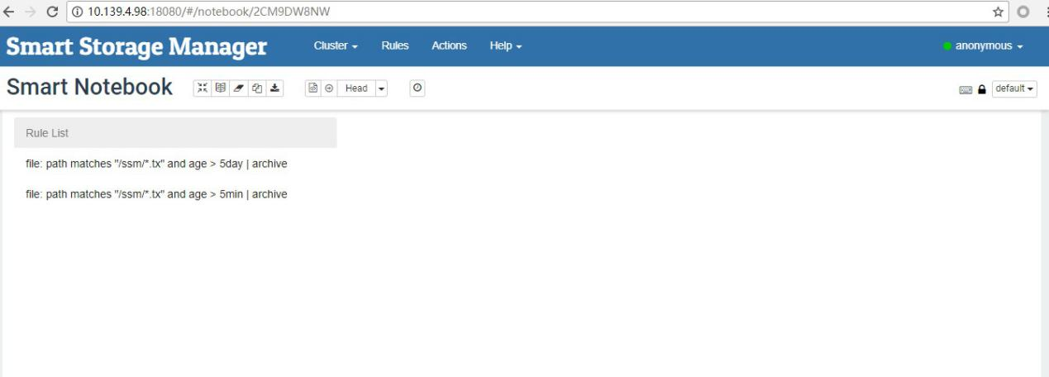

5.使用

1）添加Rules

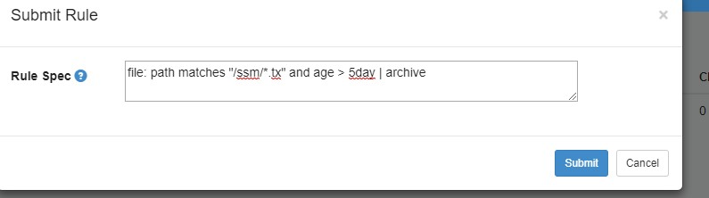

在界面上显示如下：

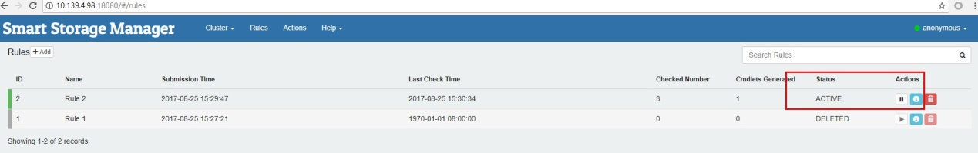

Rules为：

*file:path matches /ssm/*.tx : age>5min | archive*

当ssm目录中的tx后缀的文件，大于5分钟则移动到archive目录中。

2017-08-25 15:30:05,637 INFO org.apache.hadoop.hdfs.server.balancer.KeyManager.<init> 142: Update block keys every 2hrs, 30mins, 0sec

2017-08-25 15:30:05,669 INFO org.smartdata.hdfs.action.move.ReplicaMove.run 109: Successfully moved blk_1073744036_3212 with size=377 from DatanodeInfoWithStorage[10.139.4.98:50010,DS-5edc0c36-8903-43ac-90a0-41b702f6dc79,DISK]:DISK to 10.139.4.98:50010:ARCHIVE

2017-08-25 15:30:05,672 INFO org.smartdata.hdfs.action.move.ReplicaMove.run 109: Successfully moved blk_1073744036_3212 with size=377 from DatanodeInfoWithStorage[10.139.4.106:50010,DS-92fbdd1d-a83b-48aa-b3a5-bee18ca2b8b7,DISK]:DISK to 10.139.4.106:50010:ARCHIVE

2017-08-25 15:30:05,672 INFO org.smartdata.hdfs.action.move.ReplicaMove.run 109: Successfully moved blk_1073744036_3212 with size=377 from DatanodeInfoWithStorage[10.139.4.107:50010,DS-0d3ae7b5-0e91-4a4e-b740-a37f5eff049a,DISK]:DISK to 10.139.4.107:50010:ARCHIVE

2017-08-25 15:30:06,651 INFO org.smartdata.hdfs.action.move.MoverExecutor.executeMove 94: MoverExecutor <hdfs://cmhhost4.novalocal:8020:/ssm/tst.tx> succeeded

查看archive目录/hadoop/hdfs/archive：

.

└── subdir8

├── blk_1073744036 //多个block

└── blk_1073744036_3212.meta

$ hdfs storagepolicies -getStoragePolicy -path /ssm/tst.tx

The storage policy of /ssm/tst.tx:

BlockStoragePolicy{COLD:2, storageTypes=[ARCHIVE], creationFallbacks=[], replicationFallbacks=[]}

$hdfs fsck /ssm/tst.tx -files -blocks -locations

FSCK started by hdfs (auth:SIMPLE) from /10.139.4.98 for path /ssm/tst.tx at Fri Aug 25 15:36:25 CST 2017

/ssm/tst.tx 377 bytes, 1 block(s): OK

0. BP-1265660175-10.139.4.98-1490608404870:blk_1073744036_3212 len=377 repl=3 [DatanodeInfoWithStorage[10.139.4.106:50010,DS-9965b385-23d4-4e4a-be55-752458221480,ARCHIVE], DatanodeInfoWithStorage[10.139.4.98:50010,DS-b1ce6589-94d8-45ab-9470-8c09b41e72d6,ARCHIVE], DatanodeInfoWithStorage[10.139.4.107:50010,DS-309d17e3-4cd1-4b0a-ae86-26aa43873d51,ARCHIVE]]

ssm中放入第二个文件：tst2.tx

写入时间：

[hdfs@cmhhost4 ~]$ hdfs dfs -ls /ssm/tst2.tx

-rw-r--r-- 3 hdfs hdfs 377 2017-08-25 15:37 /ssm/tst2.tx

[hdfs@cmhhost4 ~]$ hdfs fsck /ssm/tst2.tx -files -blocks -locations

Connecting to namenode via http://cmhhost4.novalocal:50070/fsck?ugi=hdfs&files=1&blocks=1&locations=1&path=%2Fssm%2Ftst2.tx

FSCK started by hdfs (auth:SIMPLE) from /10.139.4.98 for path /ssm/tst2.tx at Fri Aug 25 15:38:25 CST 2017

/ssm/tst2.tx 377 bytes, 1 block(s): OK

1. BP-1265660175-10.139.4.98-1490608404870:blk_1073744037_3213 len=377 repl=3 [DatanodeInfoWithStorage[10.139.4.107:50010,DS-0d3ae7b5-0e91-4a4e-b740-a37f5eff049a,DISK], DatanodeInfoWithStorage[10.139.4.106:50010,DS-92fbdd1d-a83b-48aa-b3a5-bee18ca2b8b7,DISK], DatanodeInfoWithStorage[10.139.4.98:50010,DS-5edc0c36-8903-43ac-90a0-41b702f6dc79,DISK]]

默认DISK

5分钟后：

INFO org.smartdata.server.engine.cmdlet.CmdletDispatcher.dispatch 63: Dispatching cmdlet 1 to executor service class org.smartdata.server.engine.cmdlet.agent.AgentExecutorService

[hdfs@cmhhost4 ~]$ hdfs fsck /ssm/tst2.tx -files -blocks -locations

Connecting to namenode via http://cmhhost4.novalocal:50070/fsck?ugi=hdfs&files=1&blocks=1&locations=1&path=%2Fssm%2Ftst2.tx

FSCK started by hdfs (auth:SIMPLE) from /10.139.4.98 for path /ssm/tst2.tx at Fri Aug 25 15:45:26 CST 2017

/ssm/tst2.tx 377 bytes, 1 block(s): OK

1. BP-1265660175-10.139.4.98-1490608404870:blk_1073744037_3213 len=377 repl=3 [DatanodeInfoWithStorage[10.139.4.106:50010,DS-9965b385-23d4-4e4a-be55-752458221480,ARCHIVE], DatanodeInfoWithStorage[10.139.4.98:50010,DS-b1ce6589-94d8-45ab-9470-8c09b41e72d6,ARCHIVE], DatanodeInfoWithStorage[10.139.4.107:50010,DS-309d17e3-4cd1-4b0a-ae86-26aa43873d51,ARCHIVE]]

在/hadoop/hdfs/archive目录中：

└── subdir8

├── blk_1073744036

├── blk_1073744036_3212.meta

├── blk_1073744037

└── blk_1073744037_3213.meta

https://github.com/Intel-bigdata/SSM